Table of Contents

Table of Contents 1

Website Evaluation Report 2

Browser Testing: 2

Screen Size Testing: 6

HTML Validation(W3S): 12

CSS Validation(W3S): 19

Accessibility Check (Wave Tool): 20

Conclusion: 30

References: 31

Website Evaluation Report

# Browser Testing:

**Browsers tested:**

* Google Chrome
* Mozilla Firefox
* Microsoft Edge

Tests were conducted across three different web browsers; each page was analysed for inconsistencies in colour and formatting. The website is displayed consistently across all the browsers, with no noticeable differences.

**Screenshots**:

Below two screenshots have been provided for each browser, to showcase consistency over different platforms.

**Chrome:**

*Attractions:*

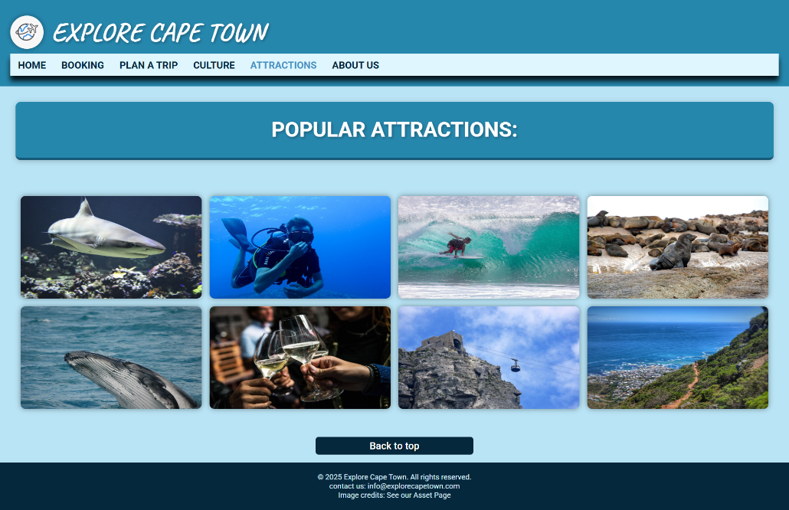

*Booking Page:*

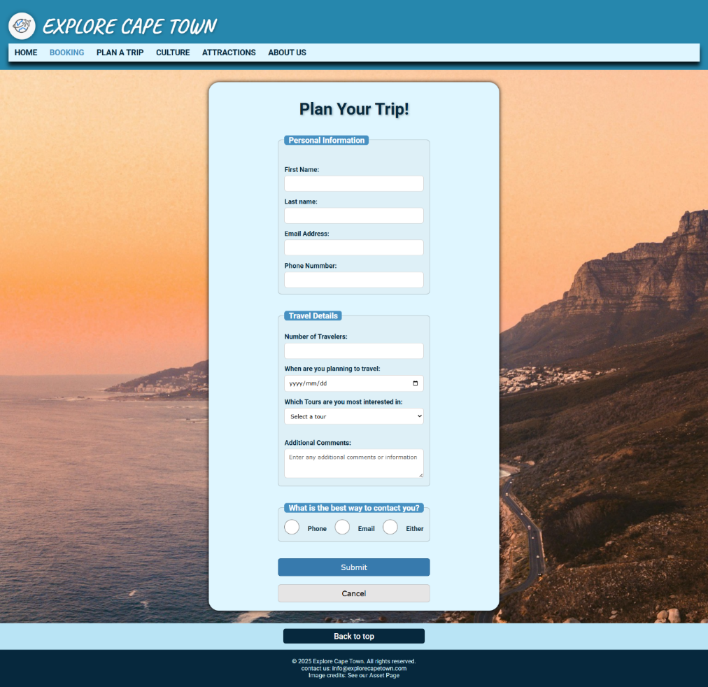

**Firefox:**

*Attractions:*

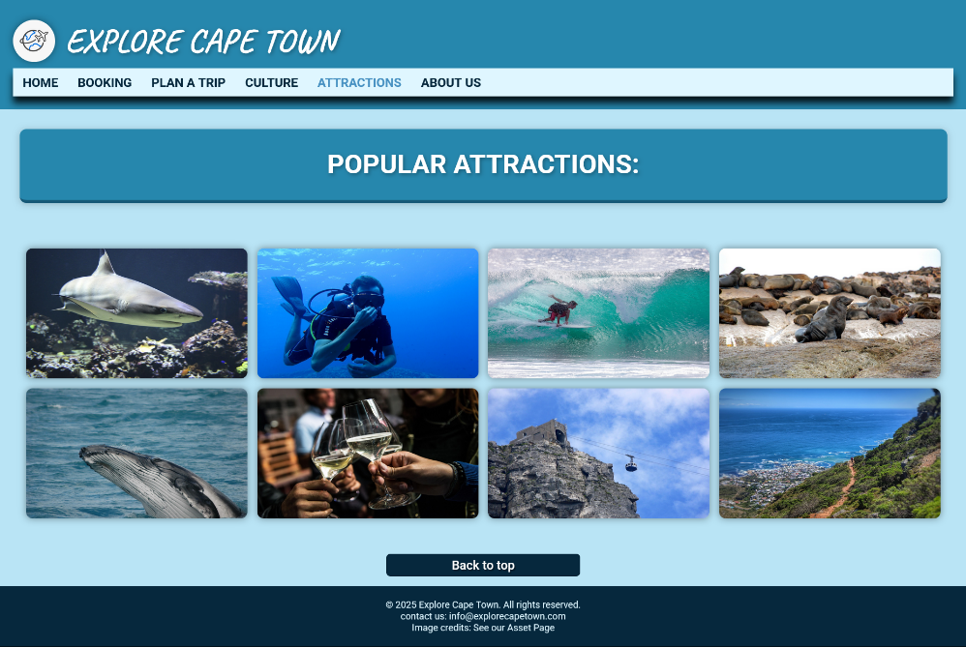

*Booking Page:*

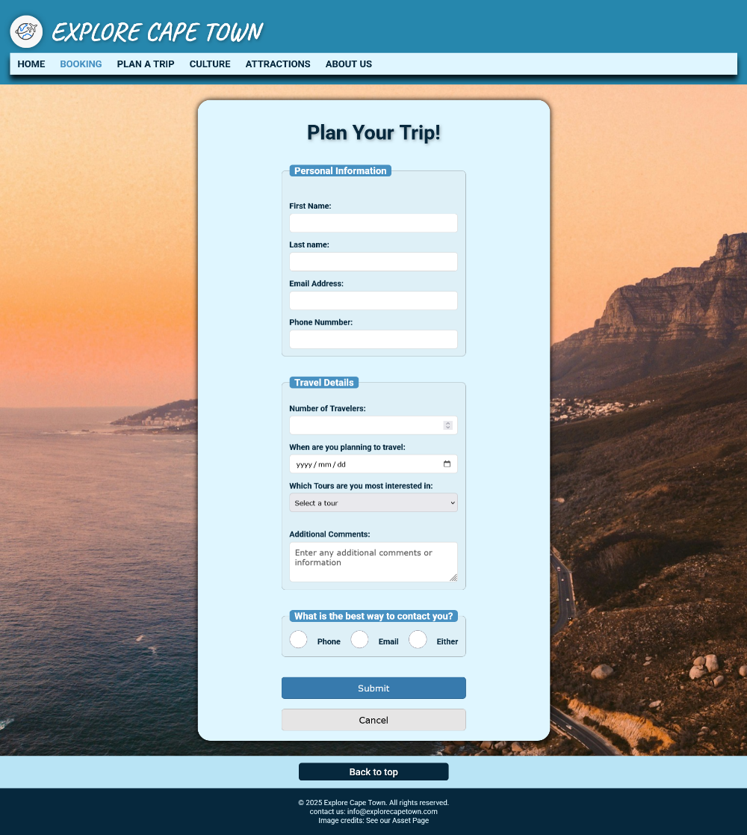

**Edge**:

*Attractions:*

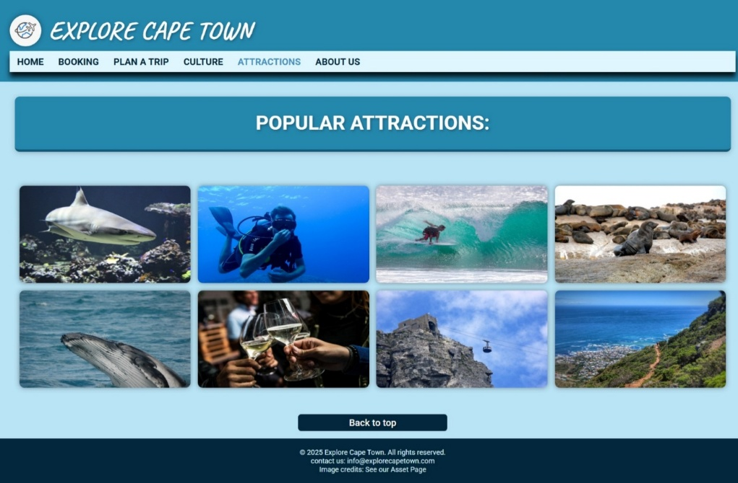

*Booking Page:*

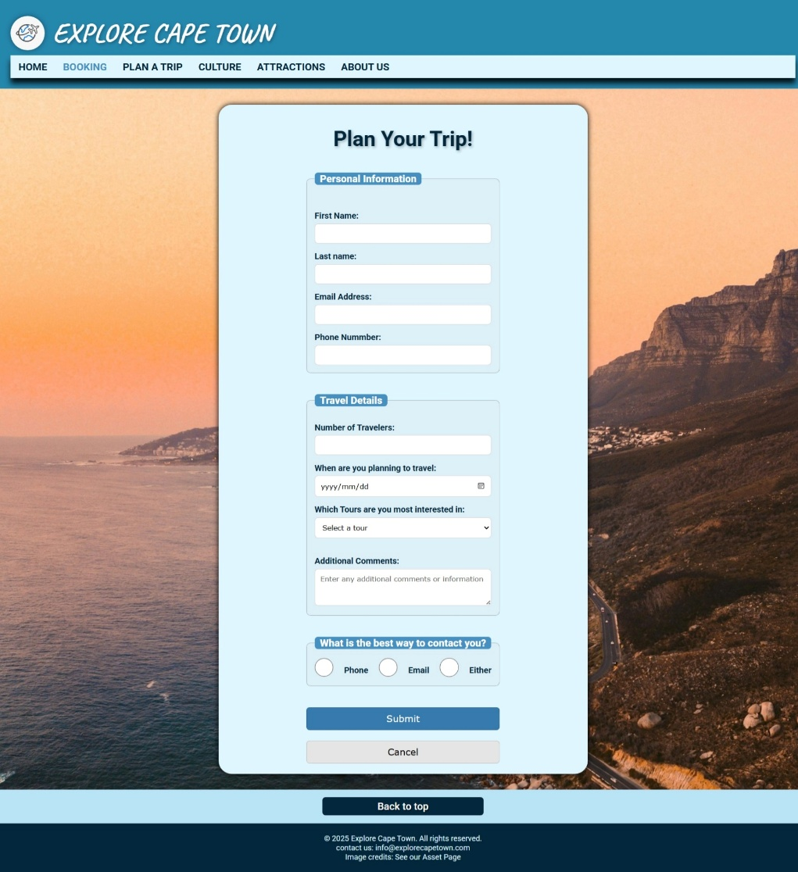

# Screen Size Testing:

**Devices Tested:**

* Samsung Galaxy S8+ (430 x 932)
* iPad Air (820 x 1180)
* PC Monitor (1920 x1080)

Tests were conducted across three different screen sizes. The aim was to test the responsiveness of this webpage, ensuring it adapts to multiple screens sizes. The result of the test was successful as the webpage responds accordingly to different screen sizes.

Below two screenshots have been provided for each devices tested, to showcase responsiveness over different screen sizes. All pages have been tested and is responsive on all three devices.

**Screenshots:**

**Smartphone:**

*Attractions:*

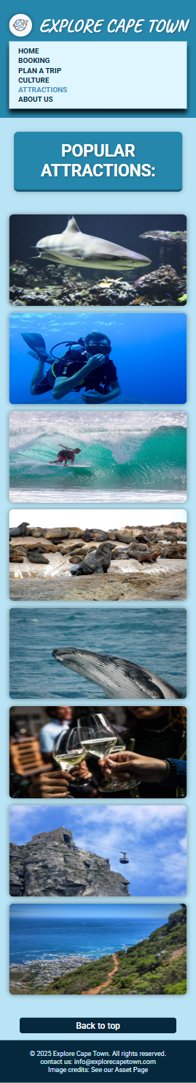

*Booking Page:*

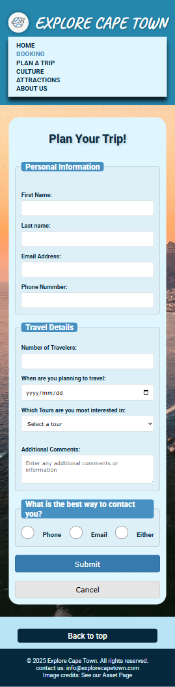

**Tablet:**

*About Us:*

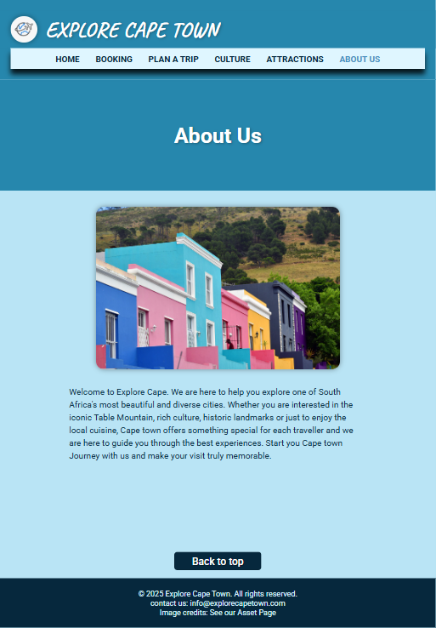

*Culture:*

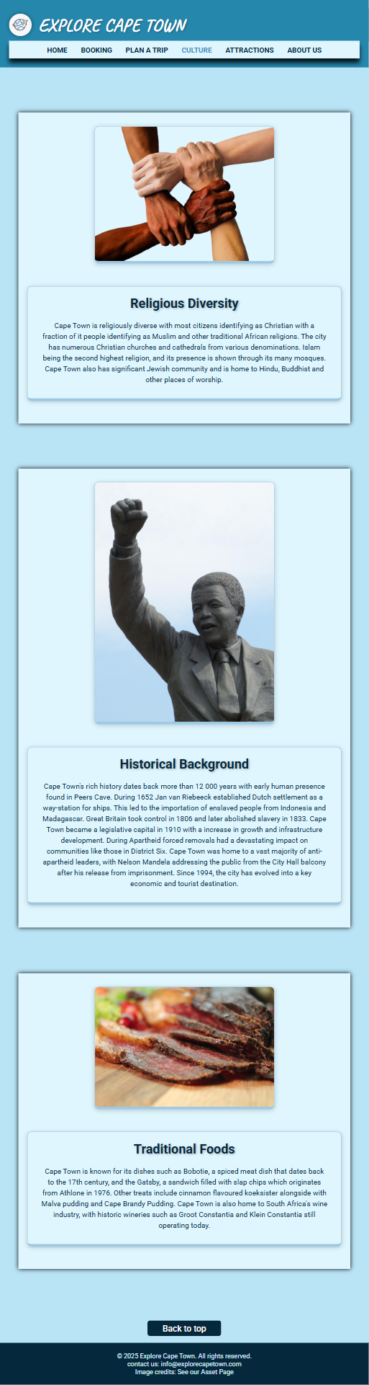

**PC Monitor**

*Home Page:*

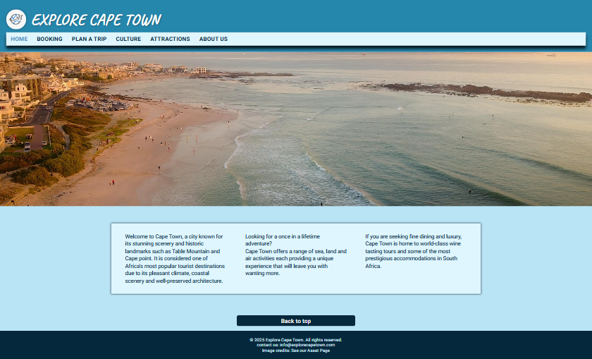

*Plan a Trip:*

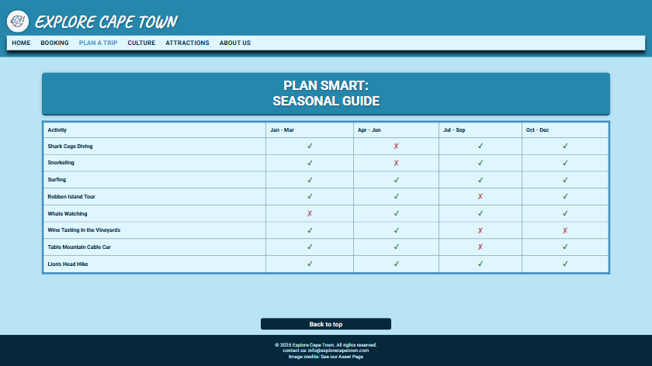

# HTML Validation(W3S):

Validations checks were carried out on the HTML of each page to ensure compliance with web standards. After completion of the website, each page underwent a validation check, where any issues were addressed accordingly.

Minor errors and warnings were identified and quickly resolved.

See screenshots of before and after the issues were fixed.

**Home Page:**

*Before:*

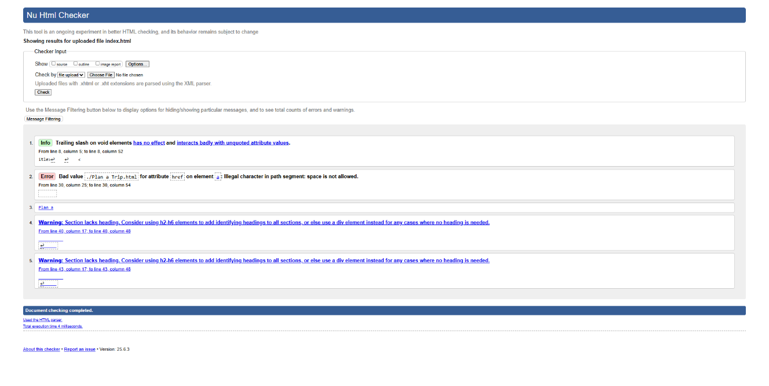

*After:*

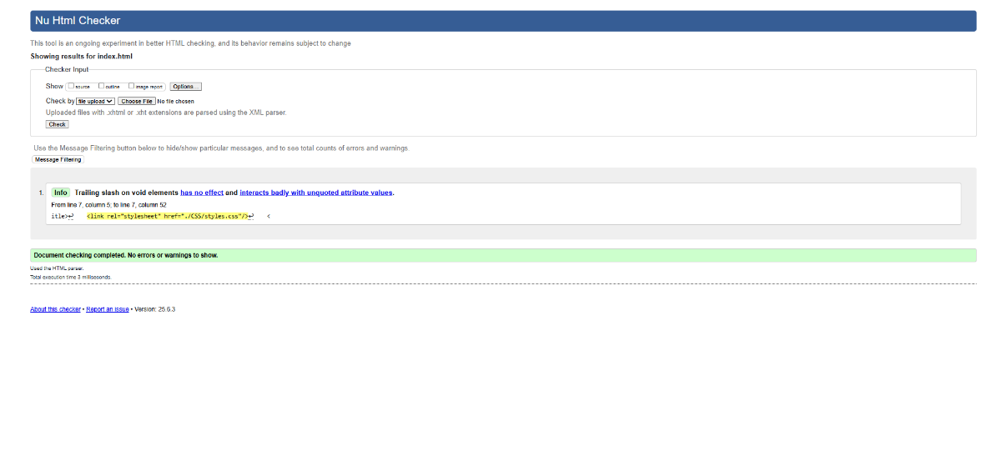

**Booking Page:**

*Before:*

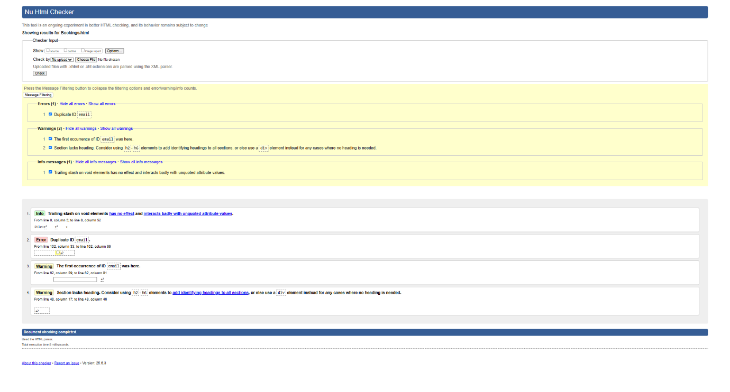

*After:*

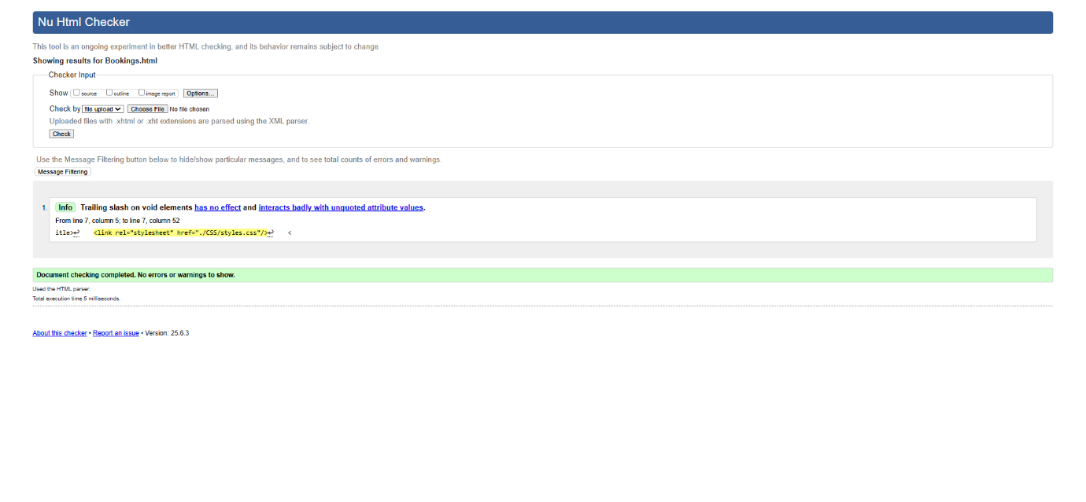

**Plan a Trip Page:**

*Before:*

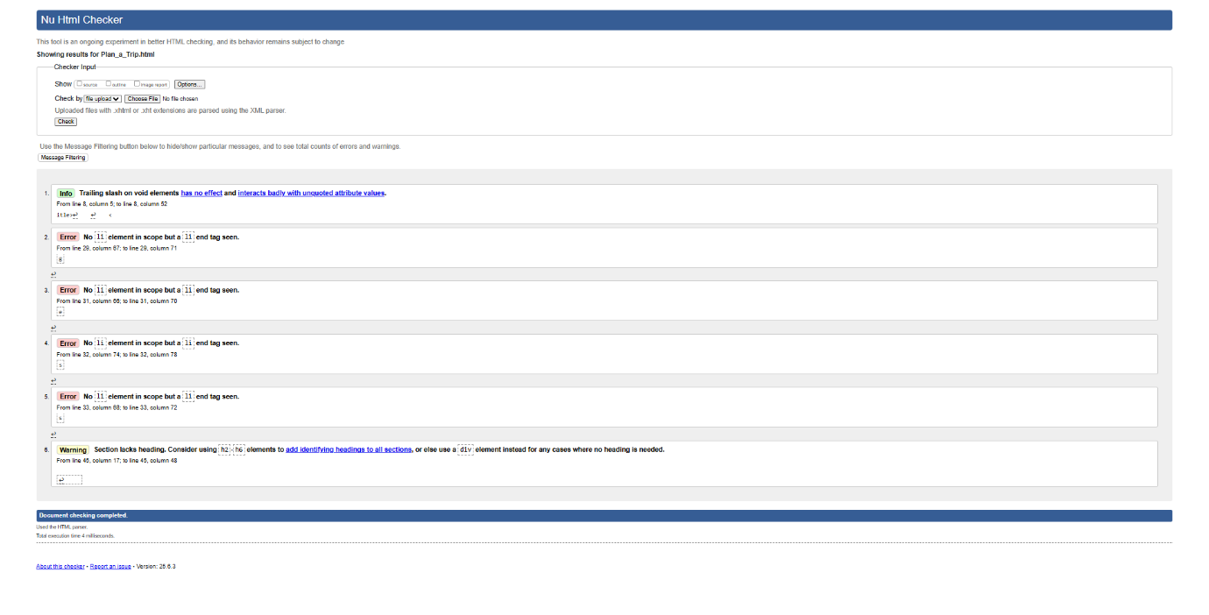

*After:*

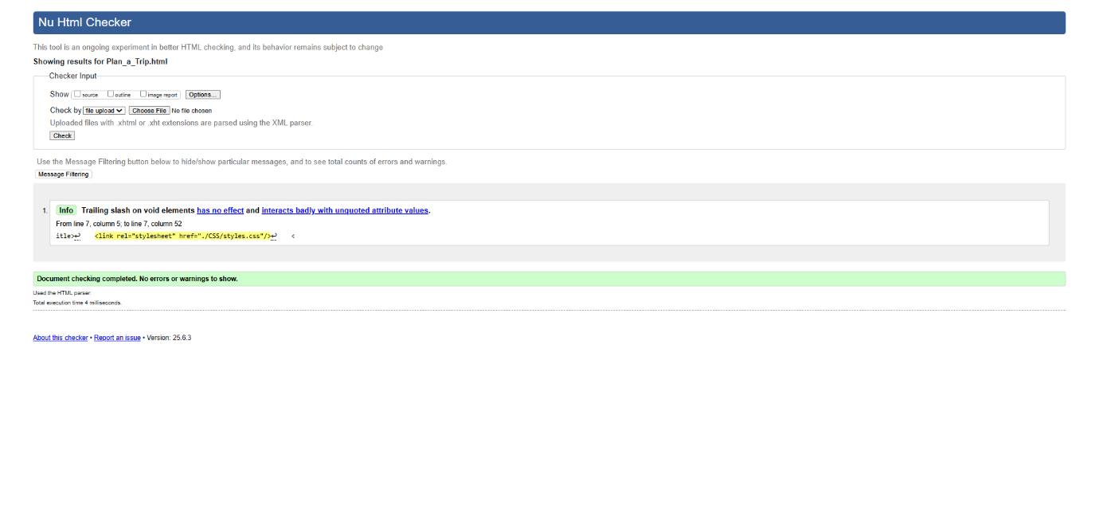

**Culture Page:**

*Before:*

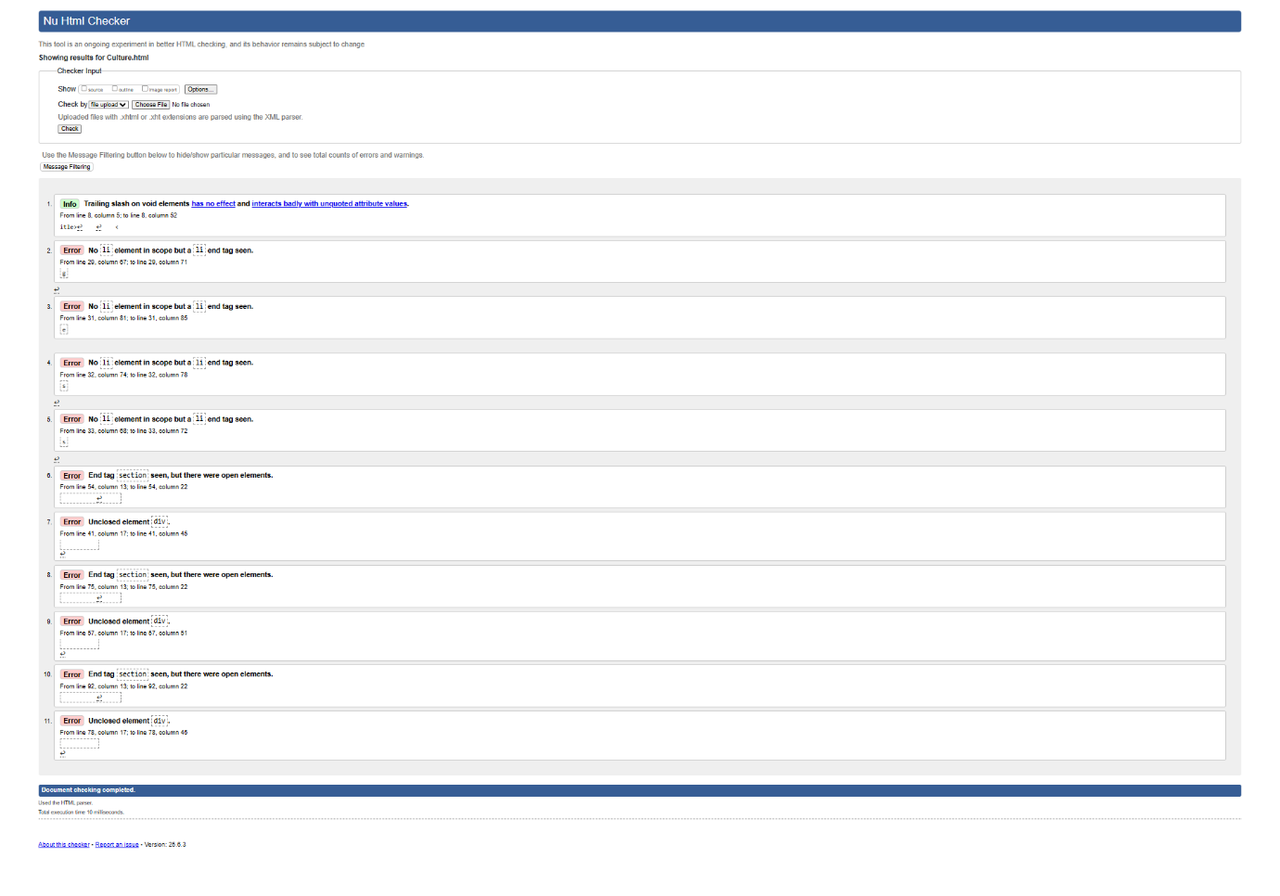

*After:*

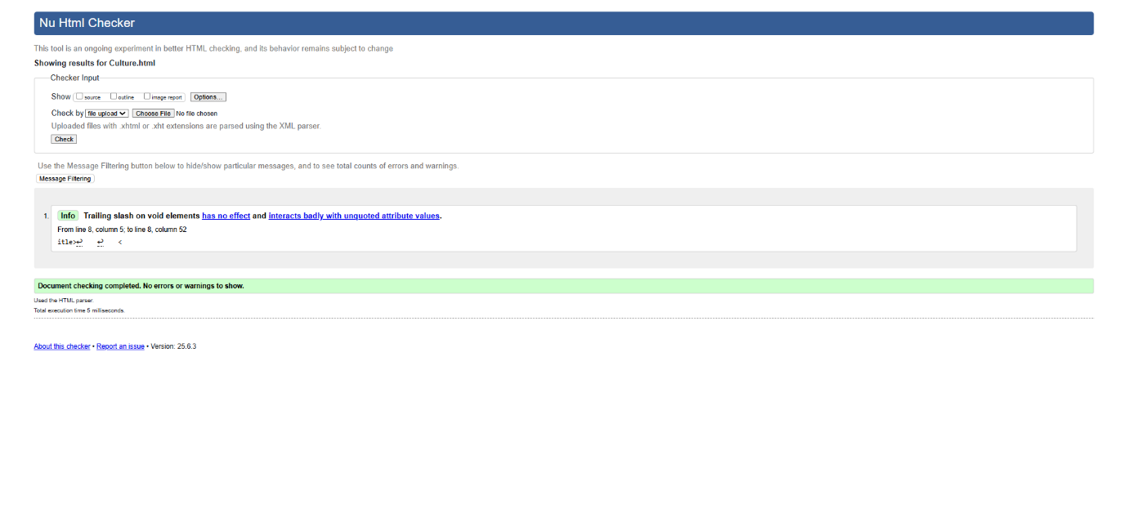

**Attractions Page:**

*Before:*

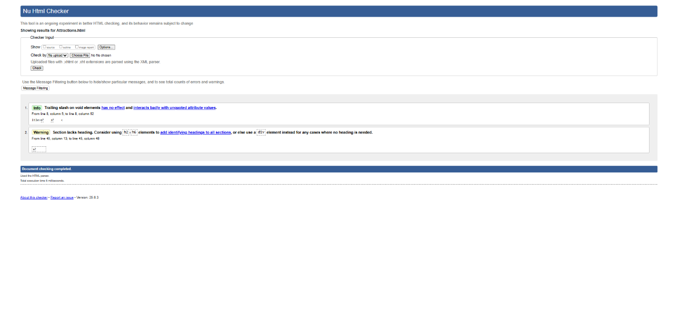

*After:*

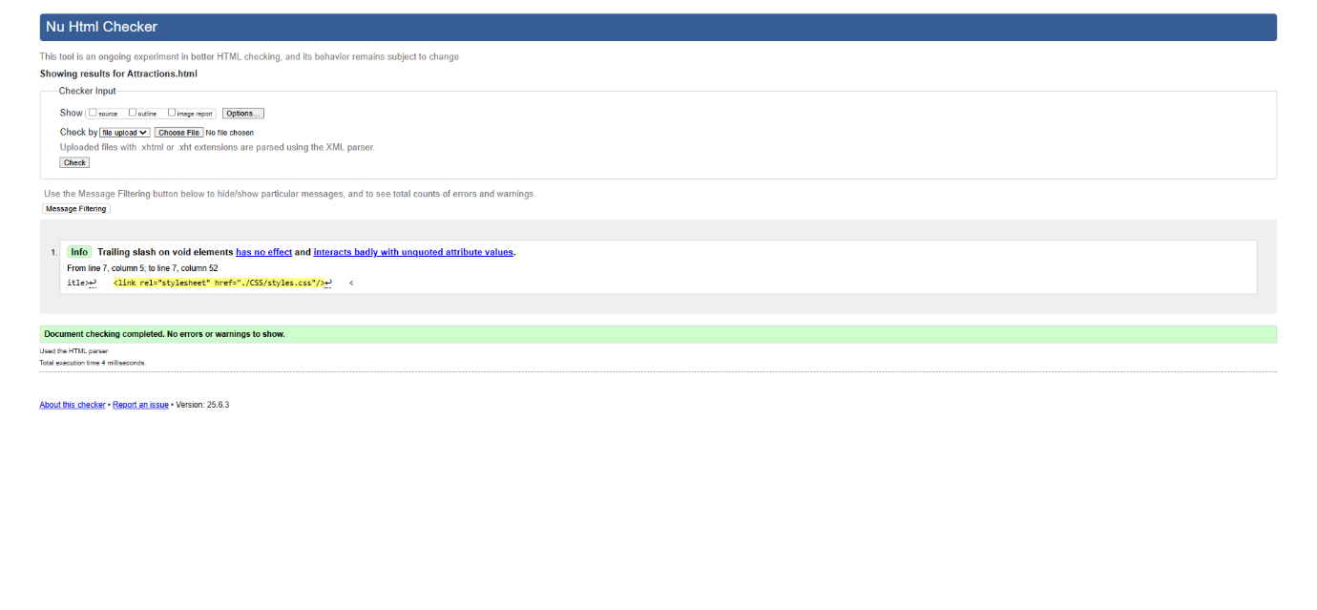

**About Us Page:**

*Before:*

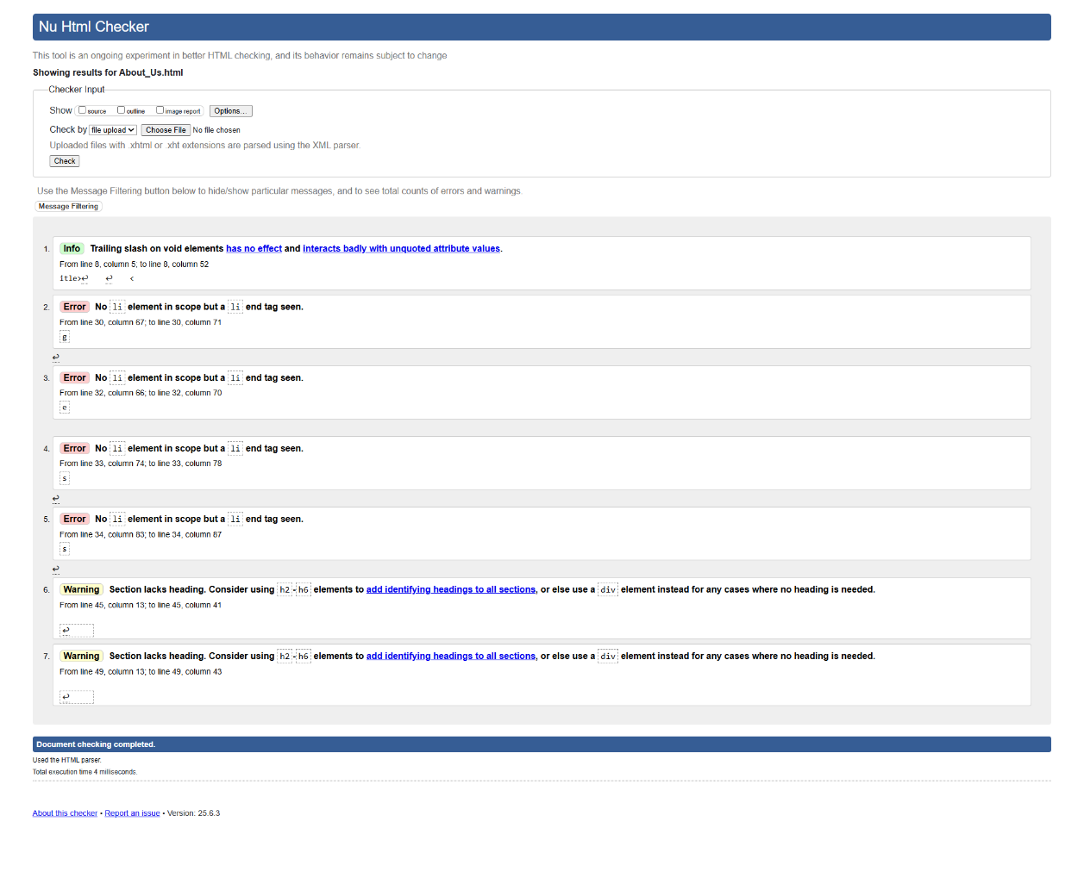

*After:*

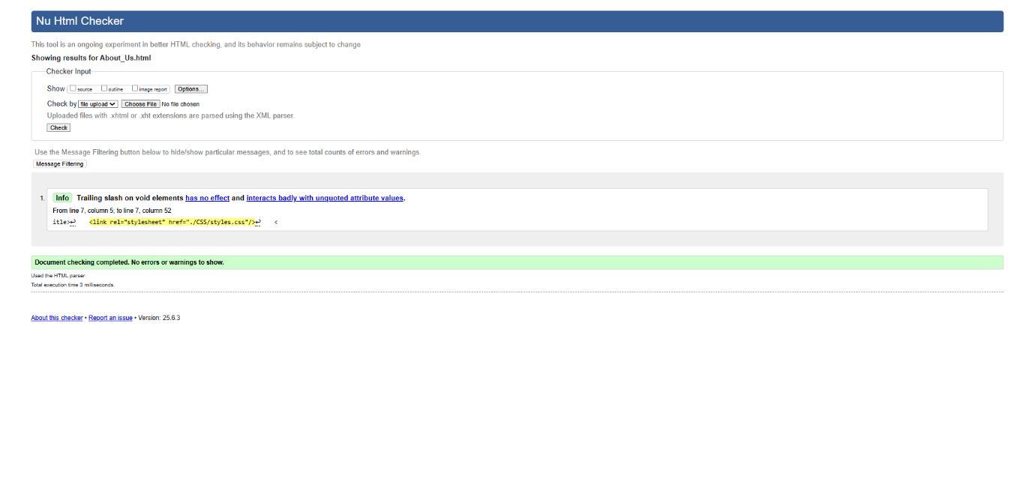

**Assets Page:**

*Before:*

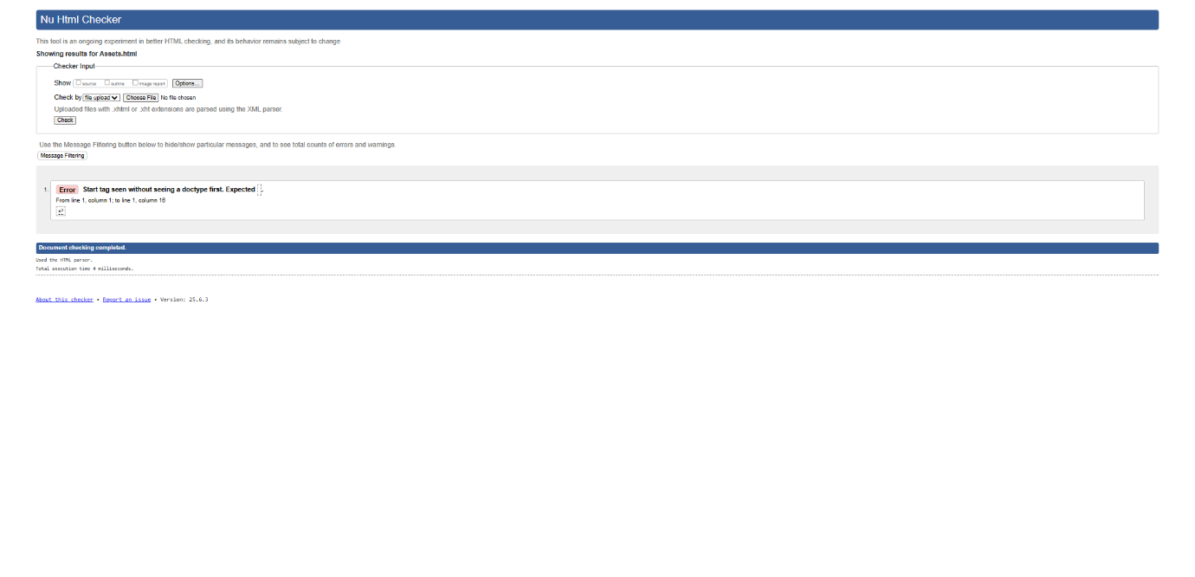

*After:*

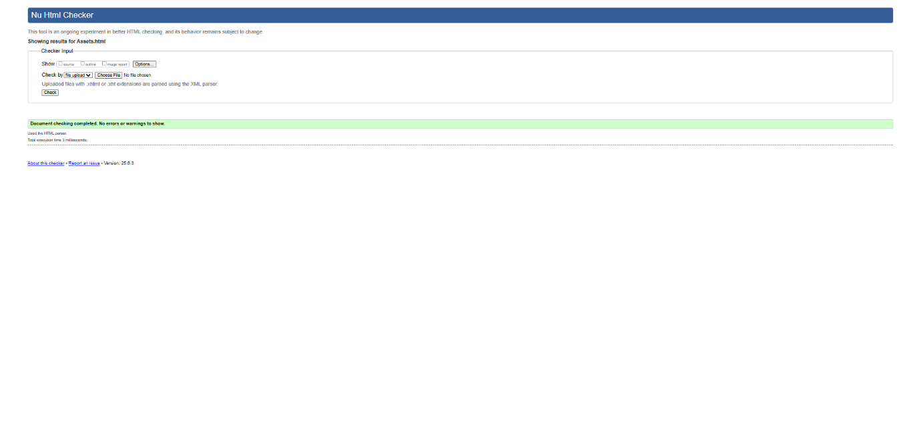

# CSS Validation(W3S):

A Validation check was performed on the CSS file of this website (note that only one CSS style sheet was used for all the web pages) This test ensures that the website complies with the web standards.

Only one CSS error was identified and quickly corrected.

*Before:*

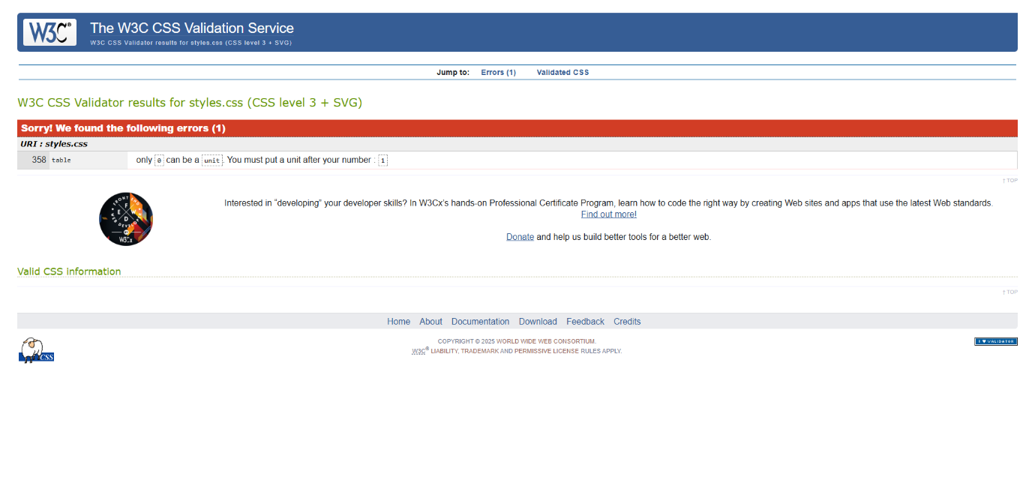

*After:*

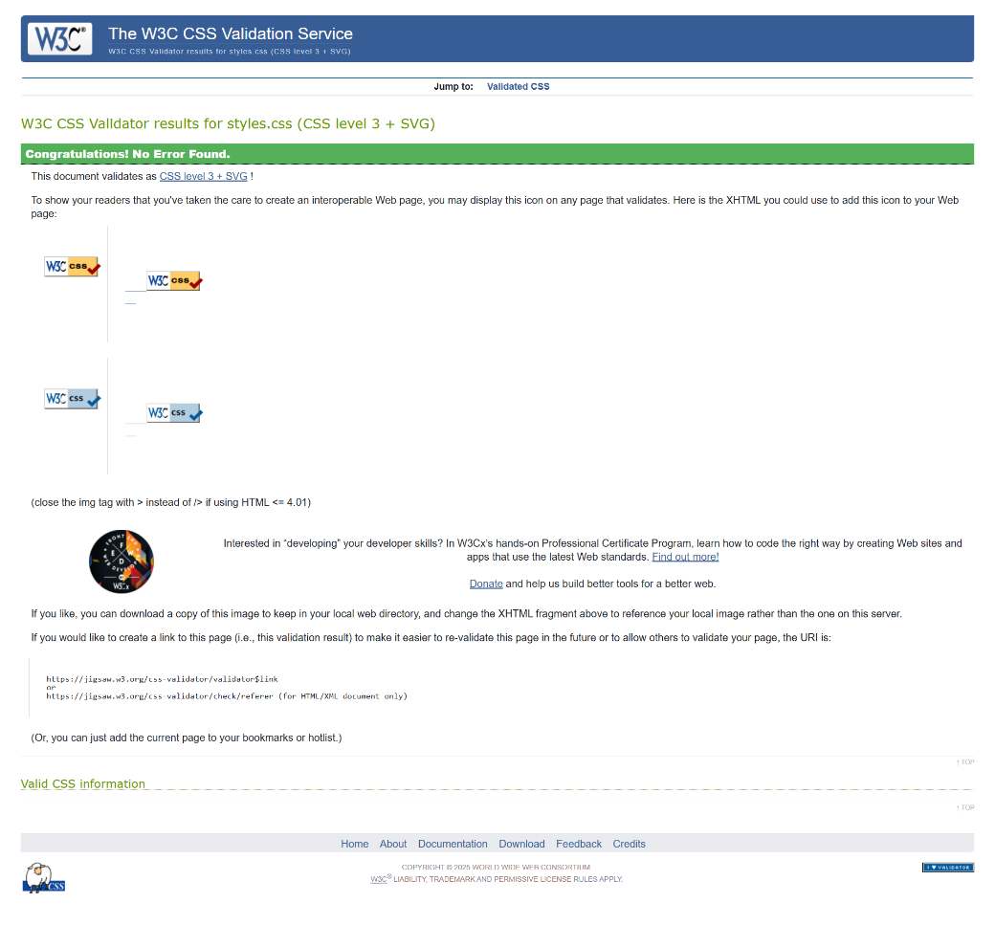

# Accessibility Check (Wave Tool):

Accessibility checks were performed on each page of the website ensuring the compliance of the accessibility standards. The wave tool extension was used on google chrome, where errors and warnings were identified and fixed.

Results indicated that some minor changes had to be implemented. This includes low contrast of certain buttons and some issues regarding form labelling and alt image text. The changes were addressed and now compliance with the standard.

**Home Page:**

*Before:*

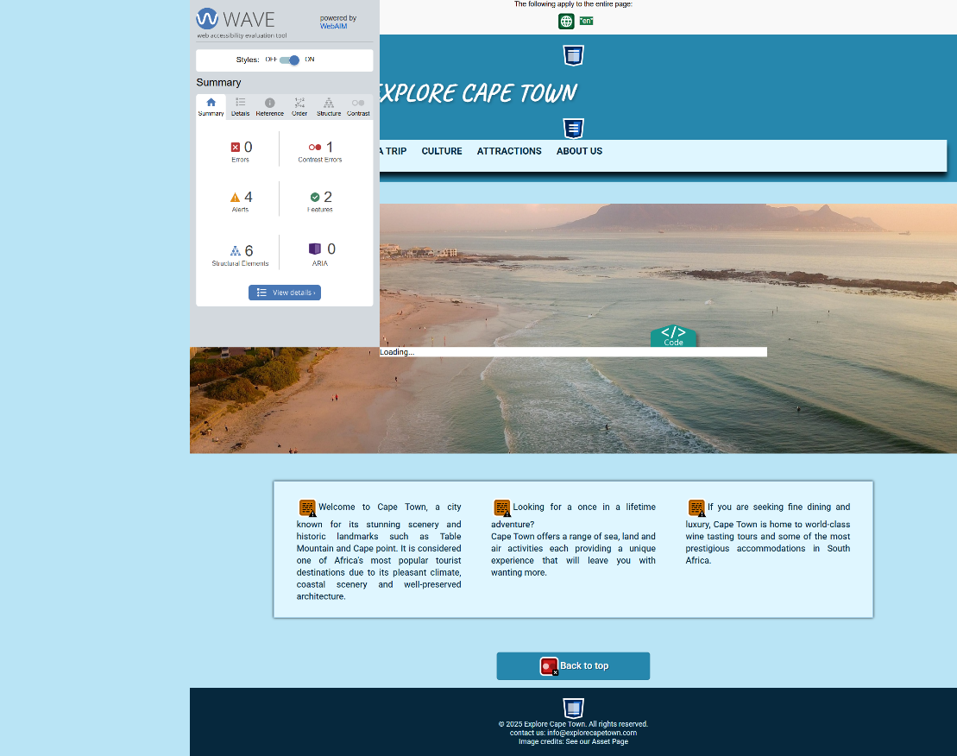

*After:*

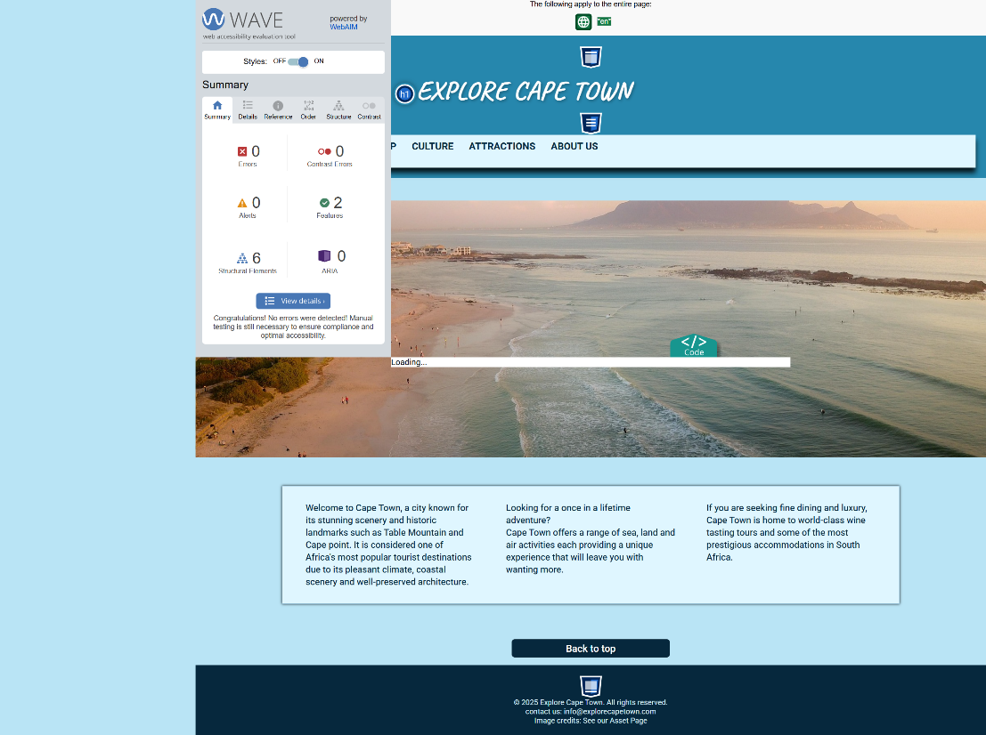

**Booking Page:**

*Before:*

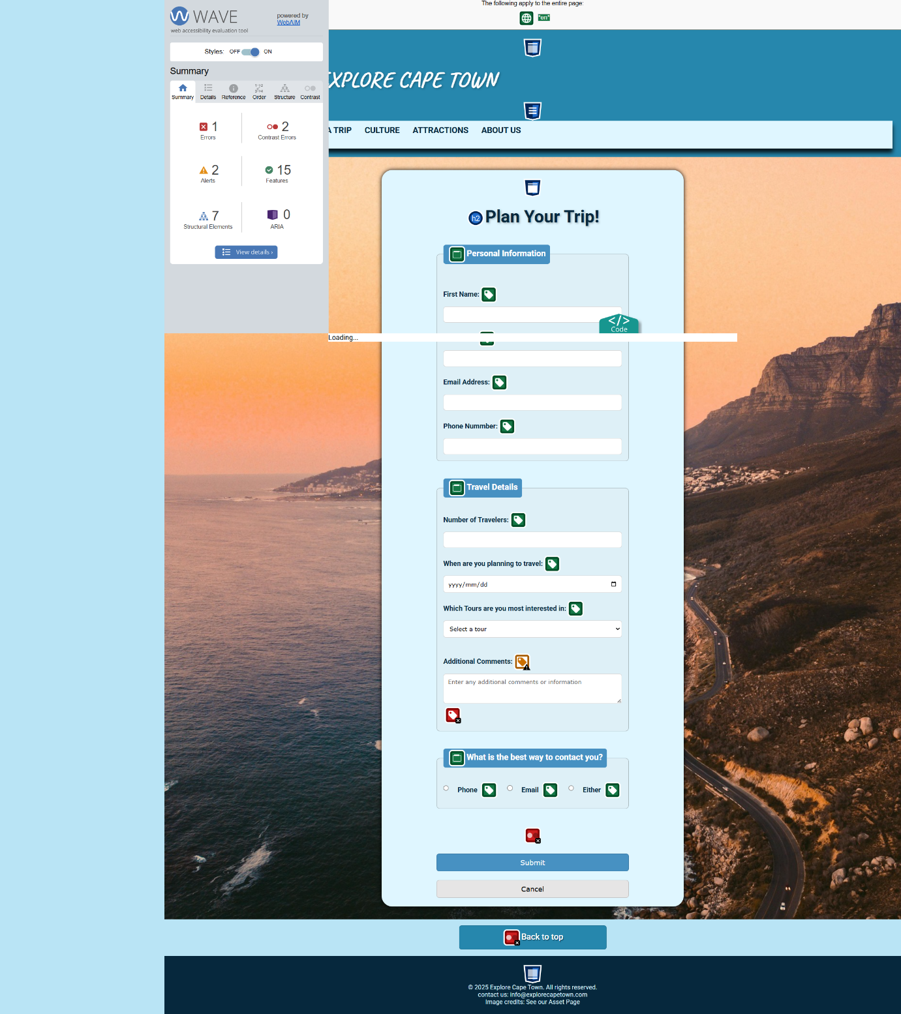

*After:*

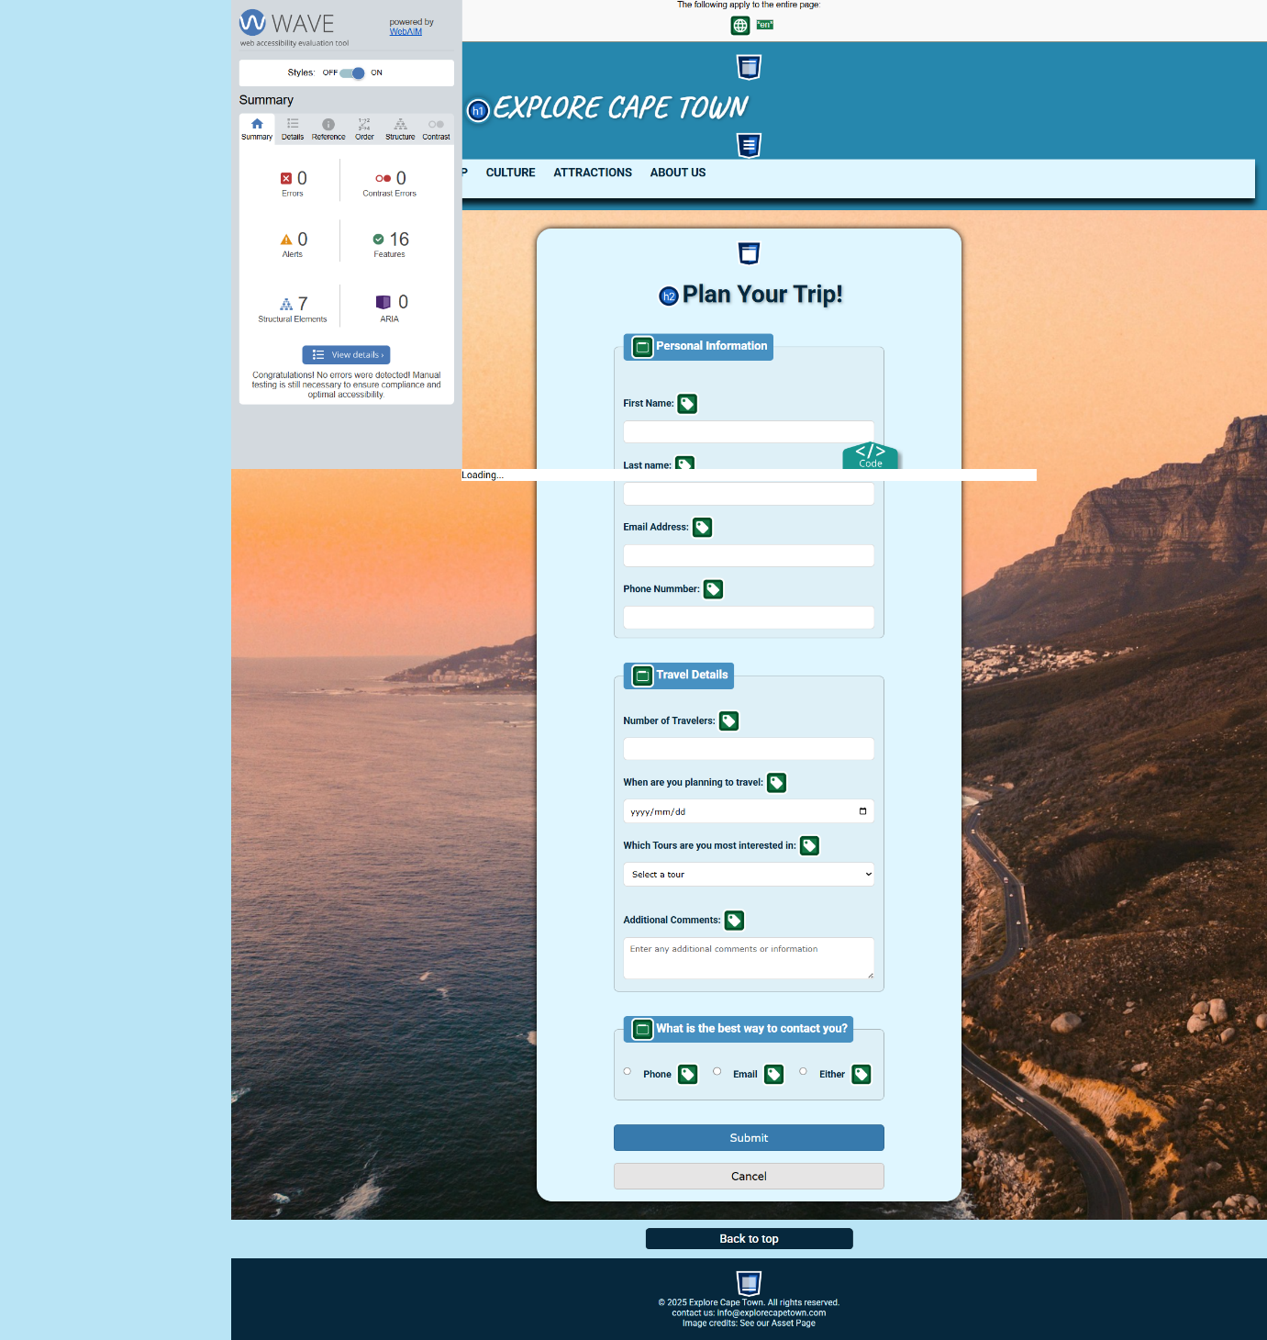

**Culture Page:**

*Before:*

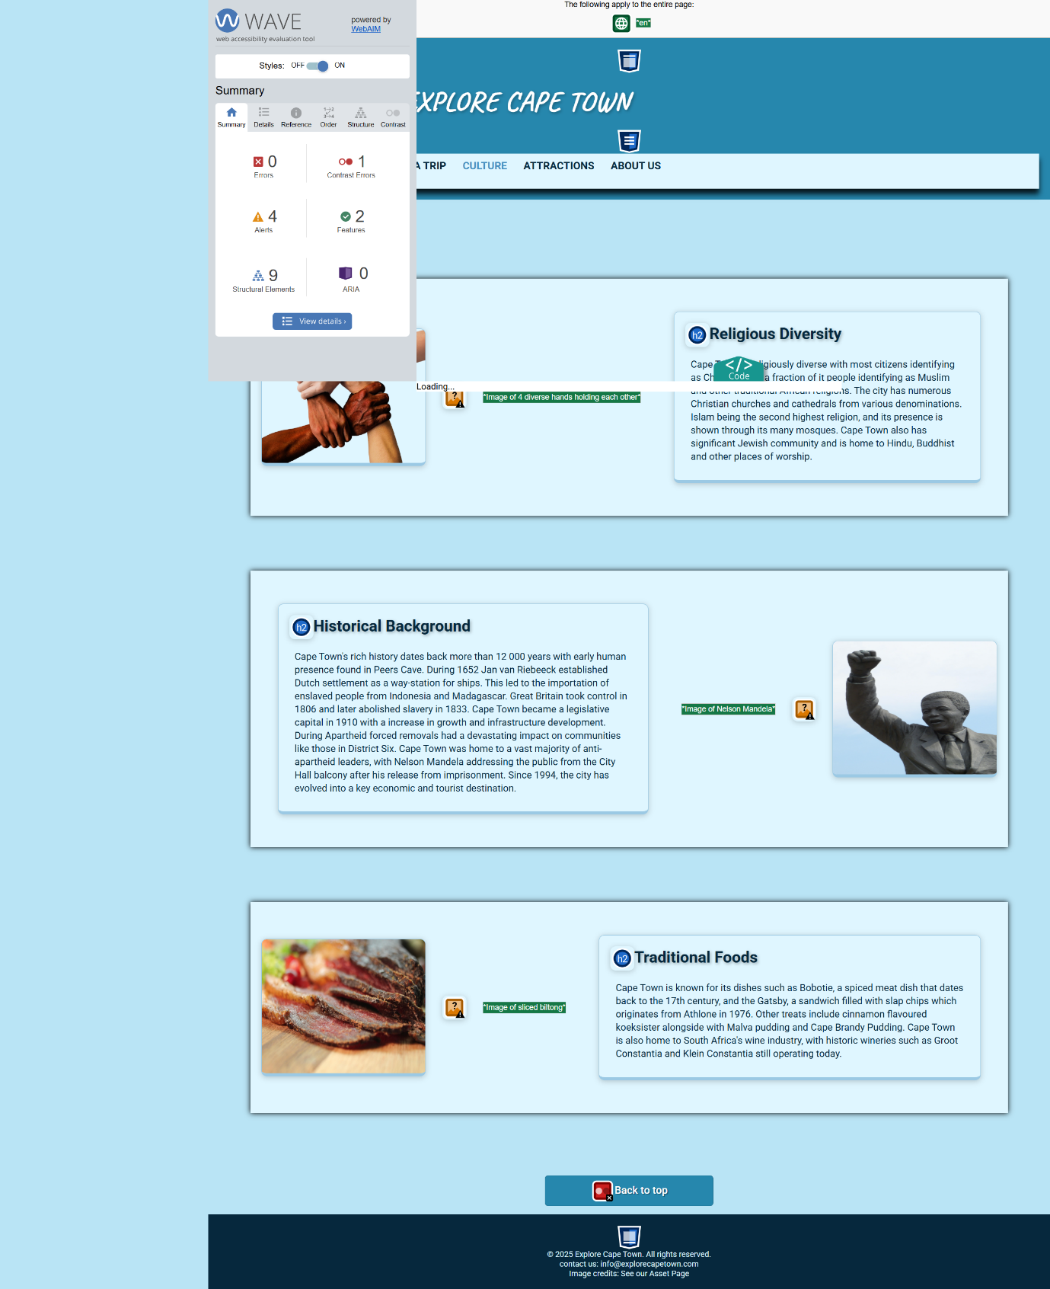

*After:*

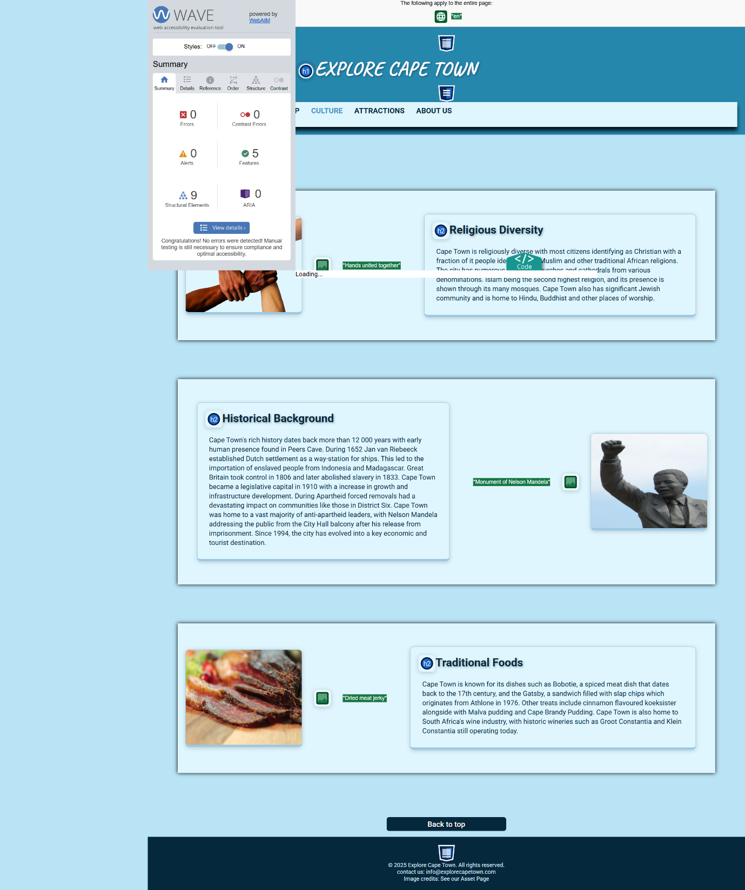

**Plan a Trip Page:**

*Before:*

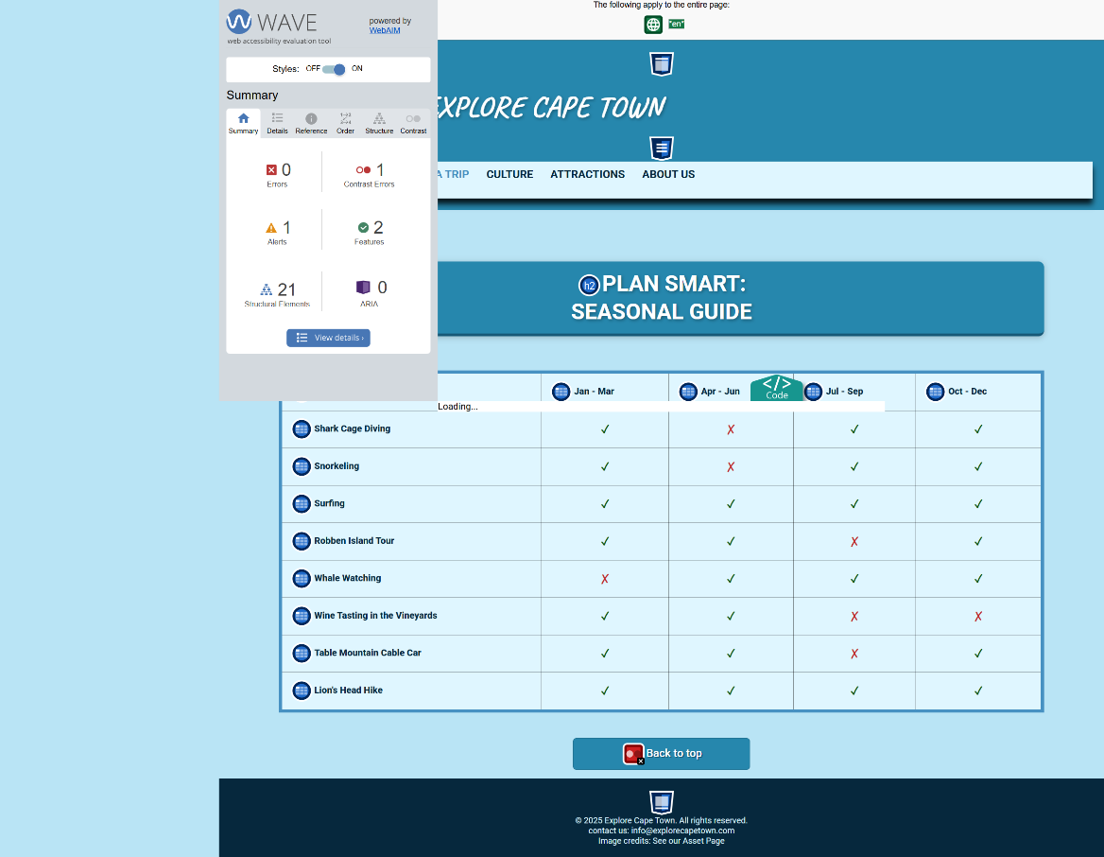

*After:*

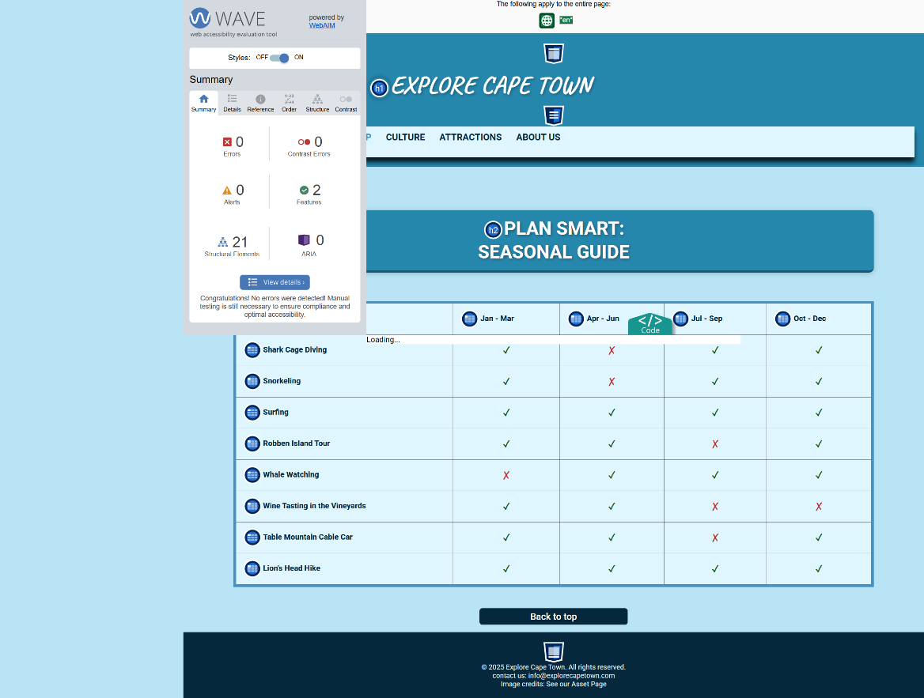

**Attractions Page:**

*Before:*

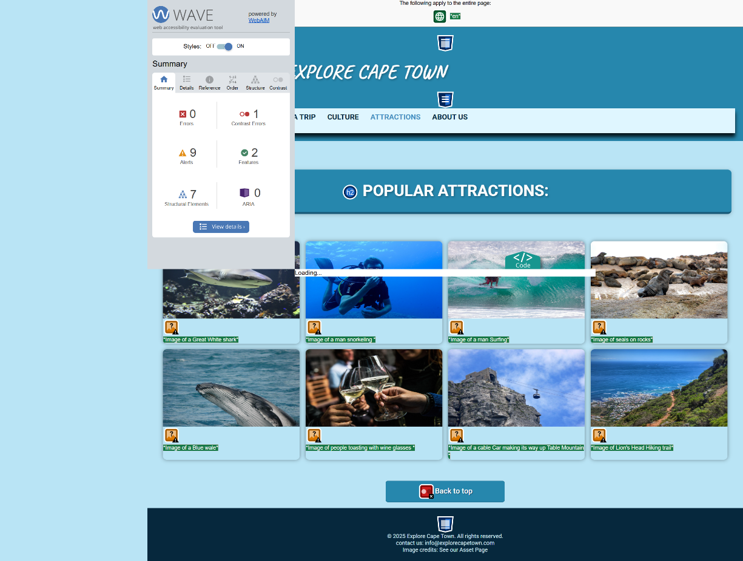

*After:*

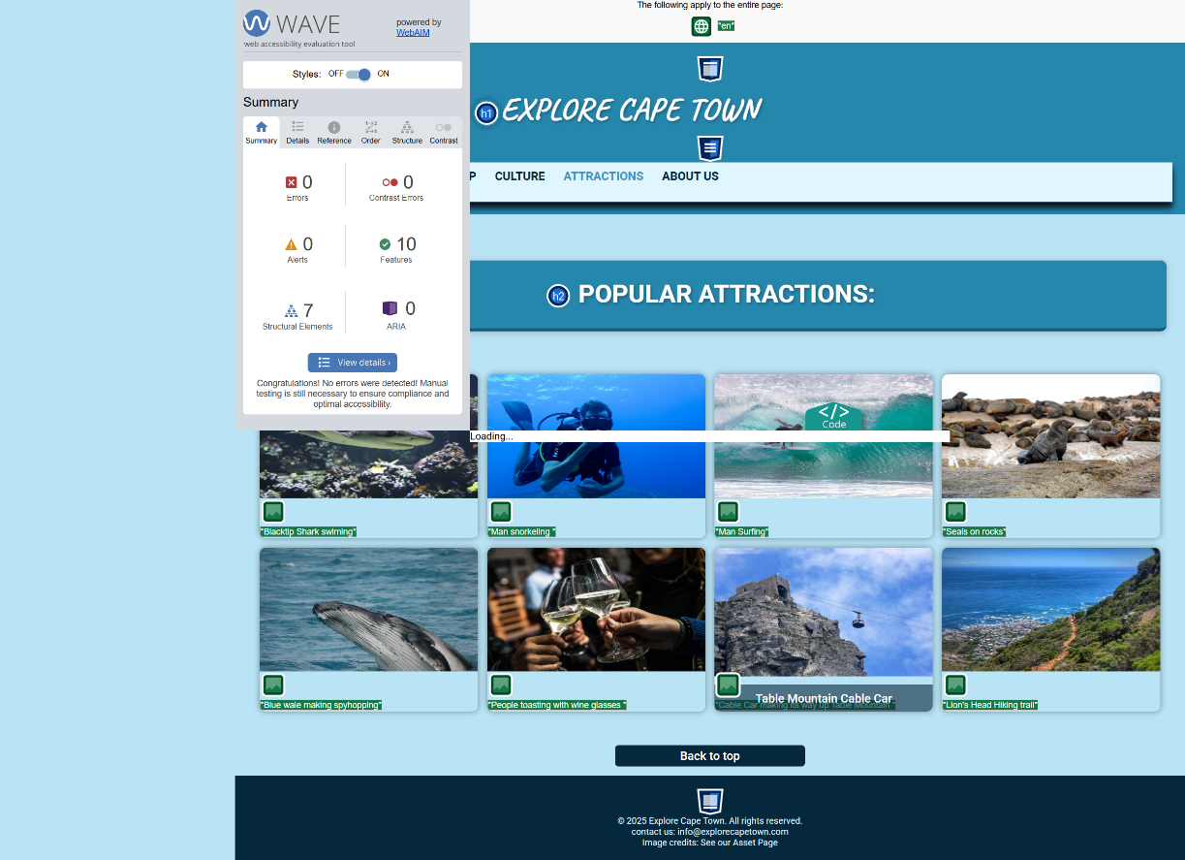

**About Us Page:**

*Before:*

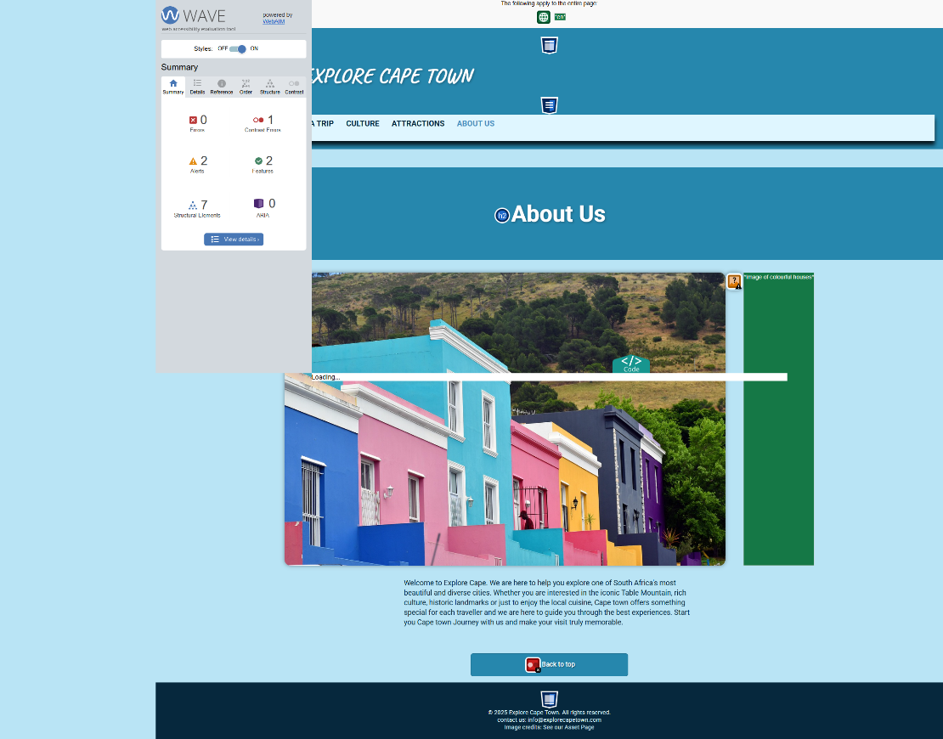

*After:*

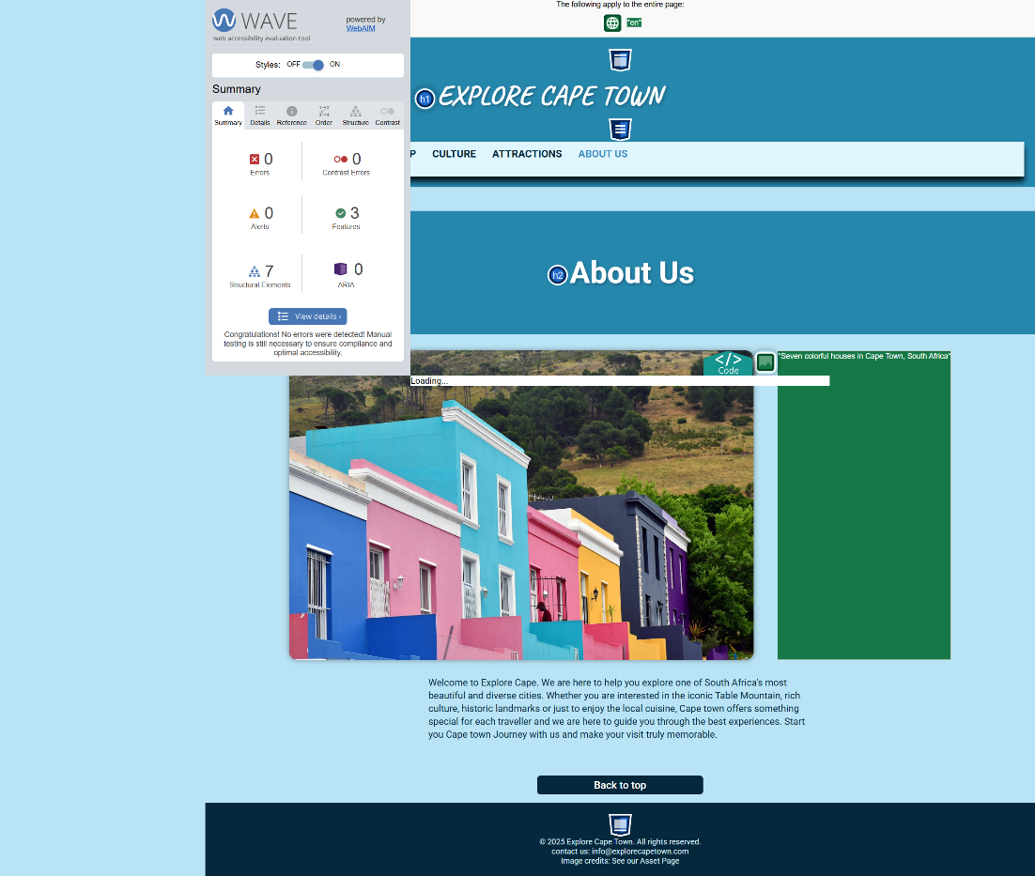

**Assets Page:**

*Before:*

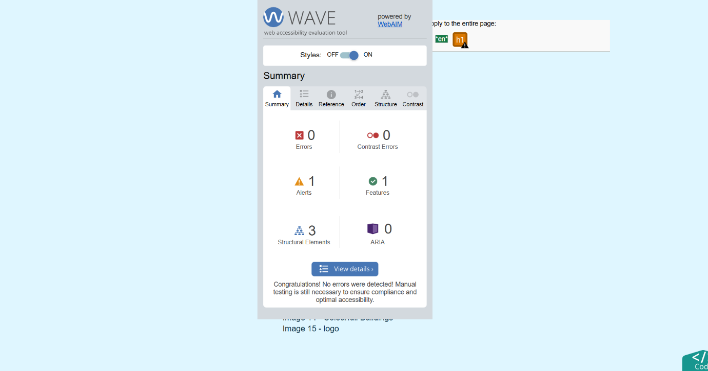

*After:*

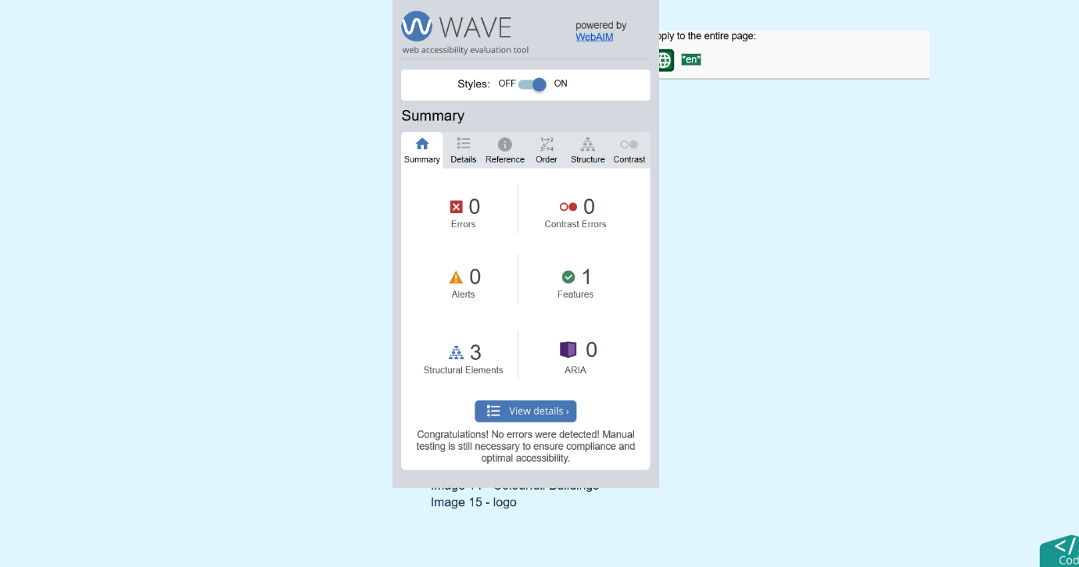

Conclusion:

All pages were tested across multiple web browsers and screen size. HTML, CSS validation was identified and resolved. Accessibility issue regarding contrast, alt image tags and form labelling were addressed using the WAVE tool. The website now meets the key accessibility and usability standards and performs responsively across various devices and browsers.

References:

Cape Town Tourism, (2022). *Cape Town Tourism.* [online]   
Available from: <https://www.capetown.travel/>   
[Accessed May 2025]

Lonely Planet, (2025). *Lonely Planet.* [online]   
Available from: <https://www.lonelyplanet.com/>   
[Accessed May 2025]

Titan Travel, n.d. *Titan Travel.* [online]   
Available *from*: <https://www.titantravel.co.uk/>   
[Accessed May 2025]

Web AIM, (n.d.). *WAVE Evaluation Tool* [online]   
Available from: <https://chromewebstore.google.com/detail/wave-evaluation-tool/jbbplnpkjmmeebjpijfedlgcdilocofh>   
[Accessed June 2025].

Wikipedia, (2025). *Cape Town.* [online]Available from:<https://en.wikipedia.org/wiki/Cape_Town>[Accessed June 2025]

W3C, (n.d.). *The Markup Validation Service* [online].   
Available from: <https://validator.w3.org/#validate_by_upload>  
[Accessed June 2025]

W3C, (n.d.). *The CSS Validation Service* [online].   
Available from: <https://jigsaw.w3.org/css-validator/>   
[Accessed June 2025]